PSP0201

Week 3

Writeup

Group Name: Blessing Software

Members

| **ID** | **Name** | **Role** |
| --- | --- | --- |
| 1211103213 | Uwais | Leader |
| 1211103149 | Dzakry Hariz | Member |
| 1211103184 | Muzaffar | Member |
|  |  |  |

**Day 6: Web Exploitation – Be careful with what you wish on a Christmas night**

**Tools used**: Kali Linux, Firefox

**Solution/walkthrough**:

Question 1

Went to the Owasp Cheat Sheet site. Search for the input validation strategies.

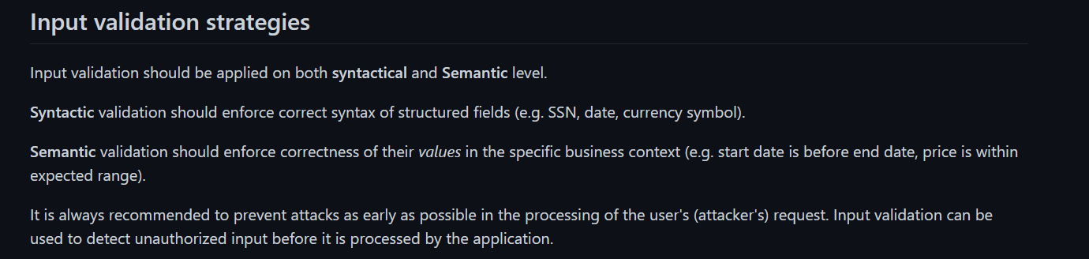

Question 2

Search for the Allow List Regular Expression Examples

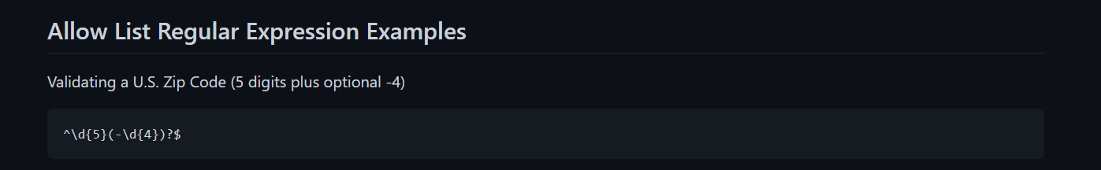

Question 3

In the site, there is a search query and submission box.

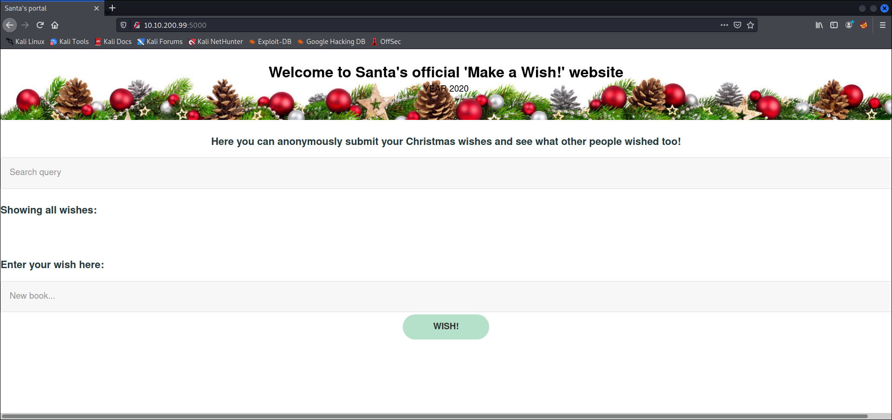

Question 4

Tried searching using the website search function.

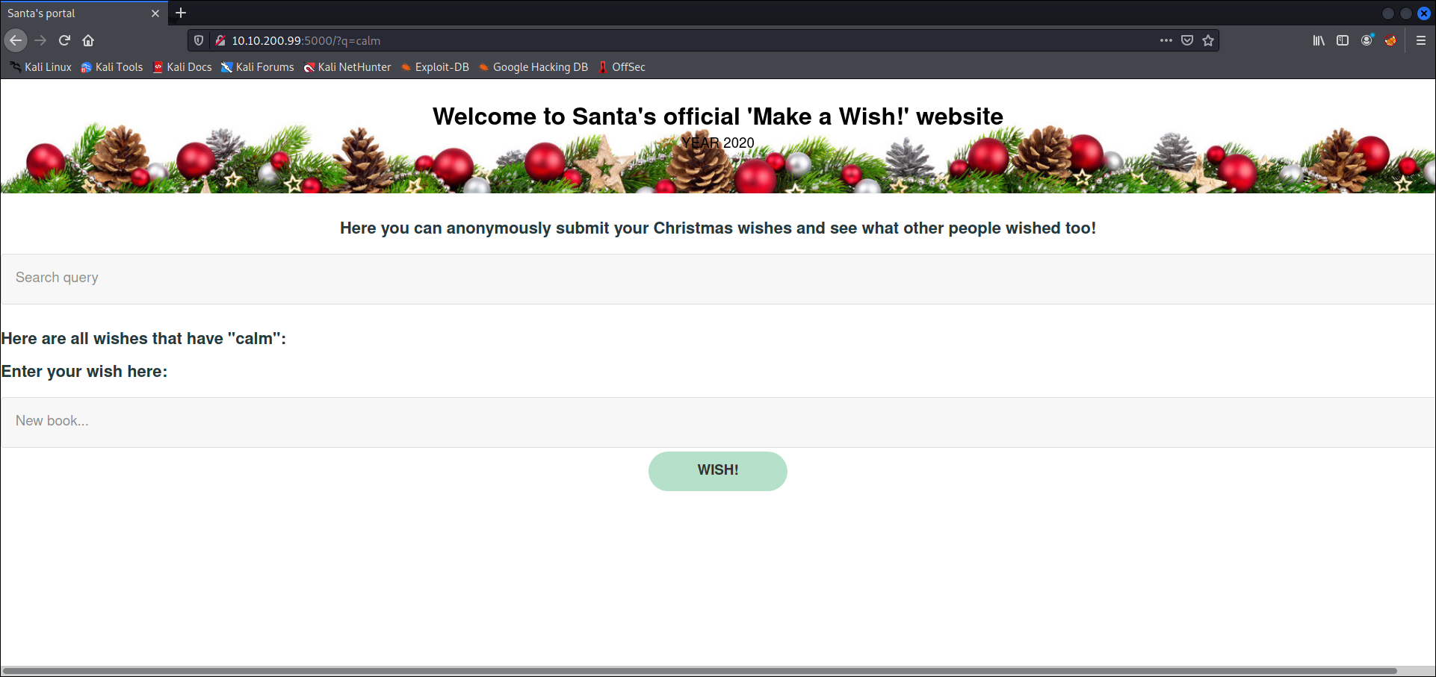

The search query showed the keyword parameter.



Question 5

Using OwaspZap, ran an Automated Scan on the website.

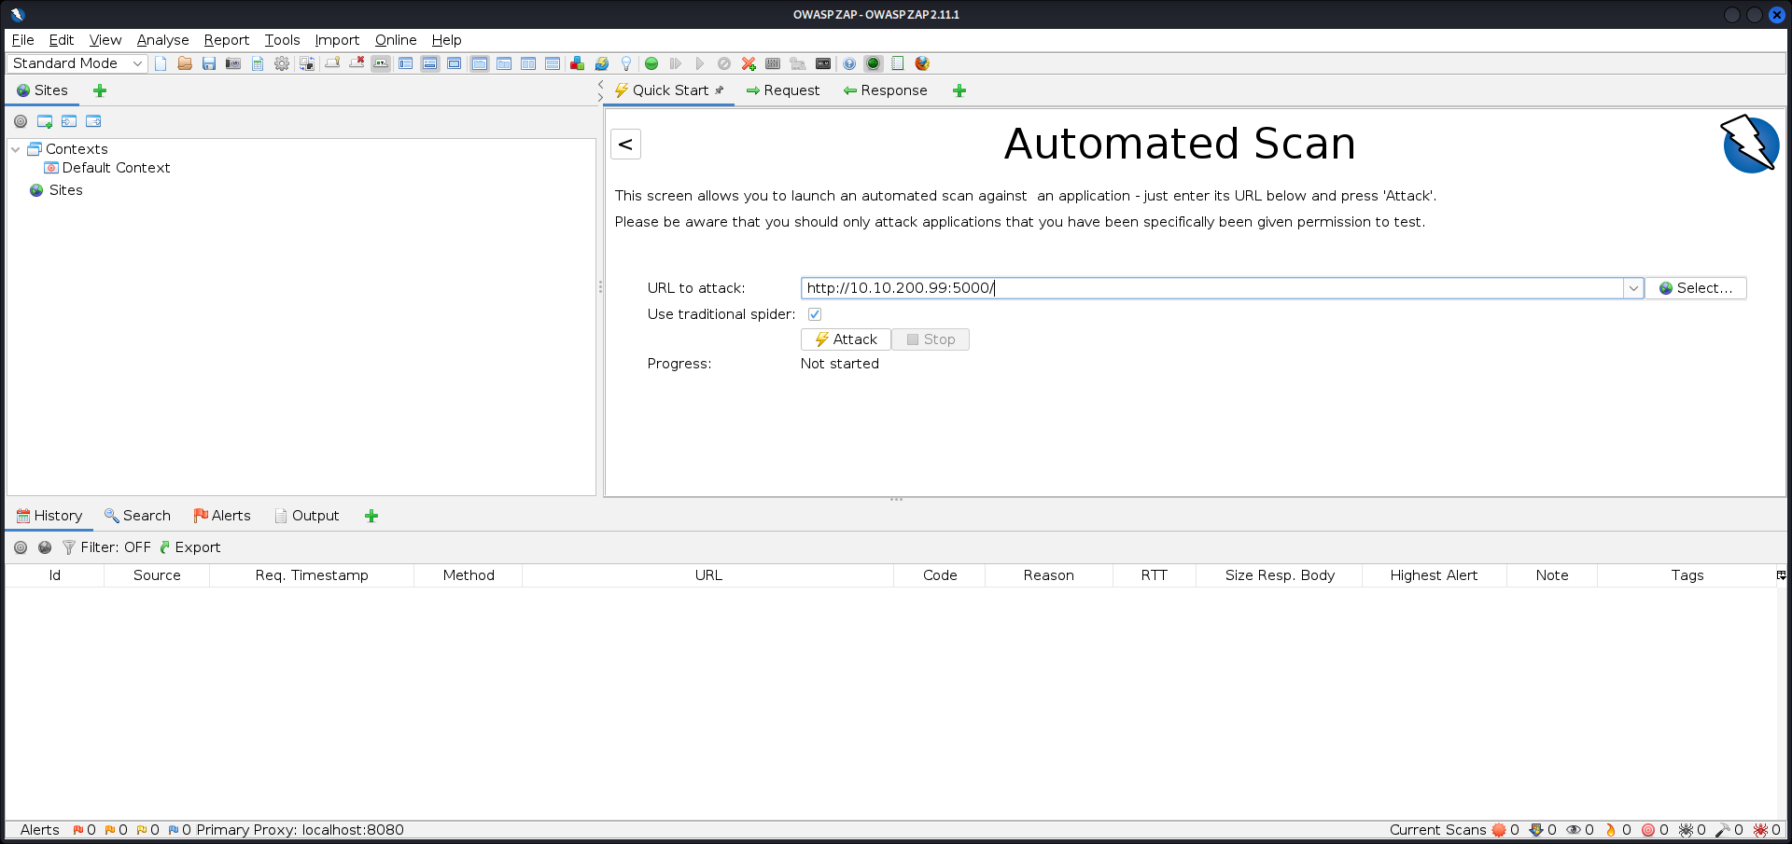

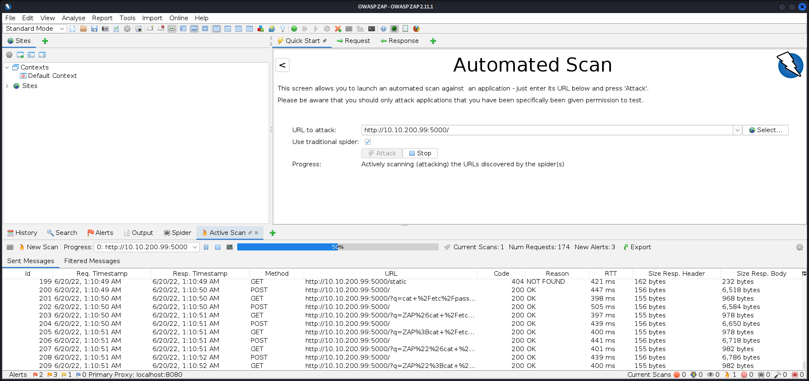

After the scan was completed, looked to the Alerts tab.

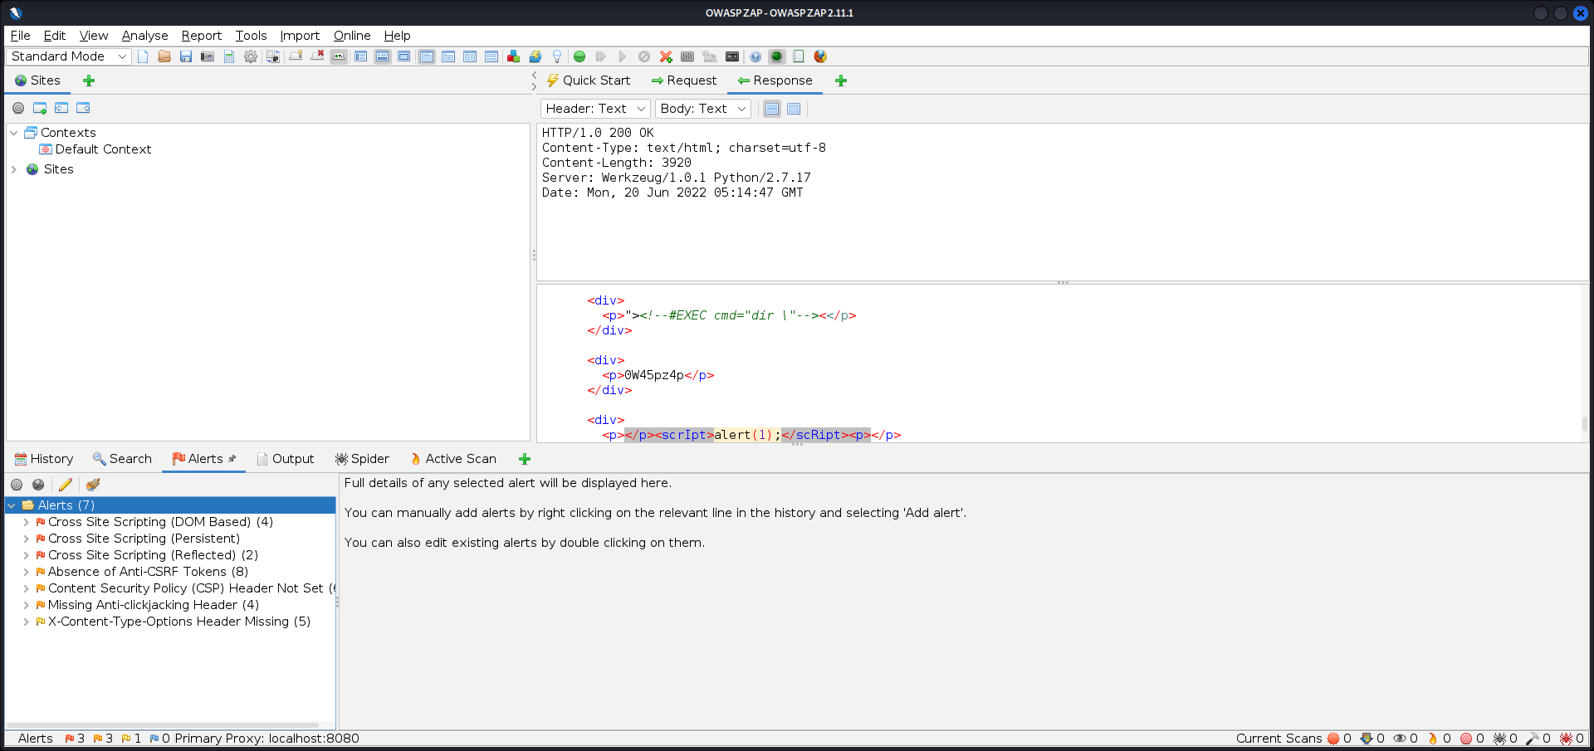

At the bottom shows the amount of high priority alerts.



Question 6

Entered the script into the wish text box.

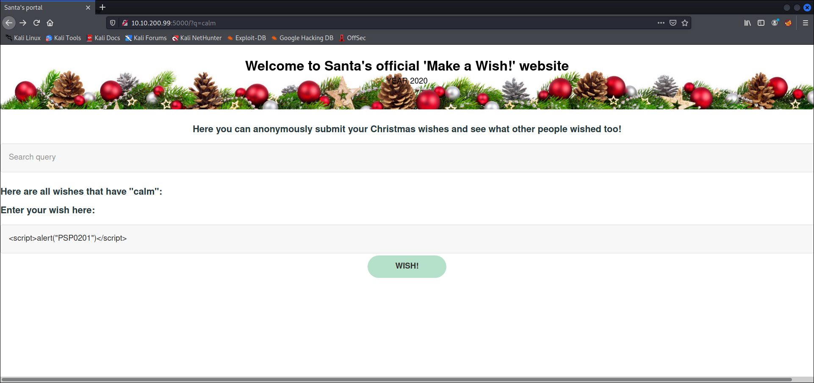

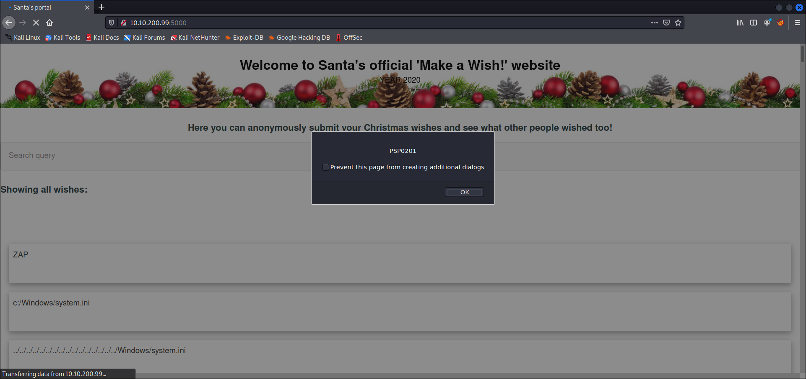

Question 7

Closed the browser, and reentered the site.

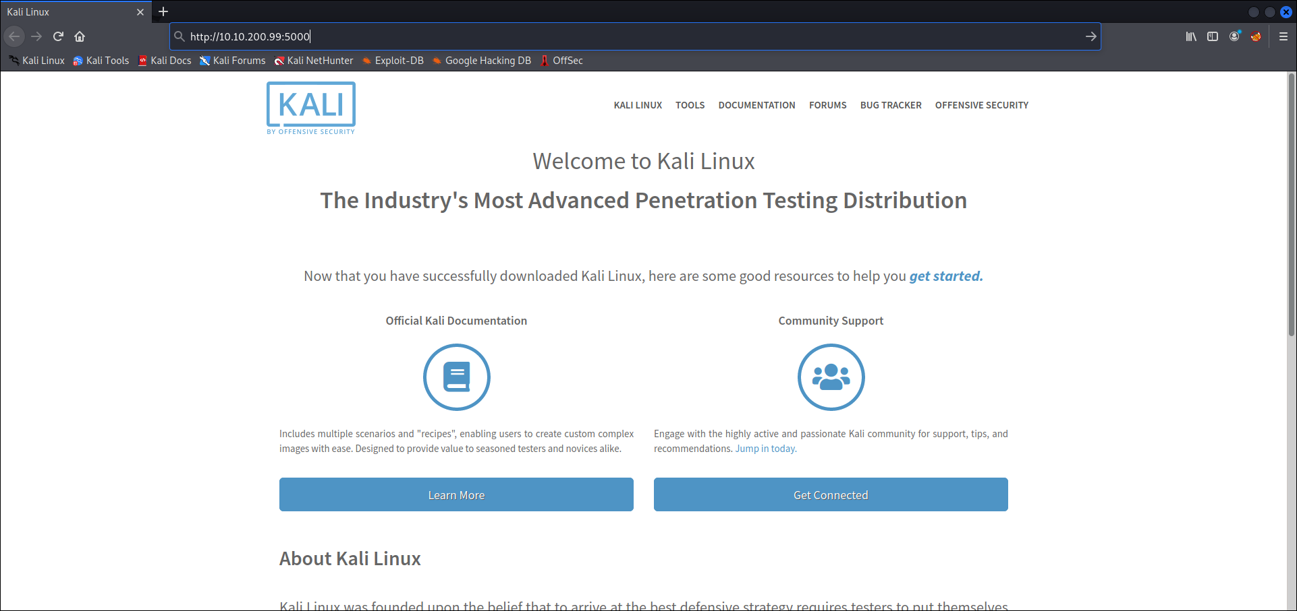

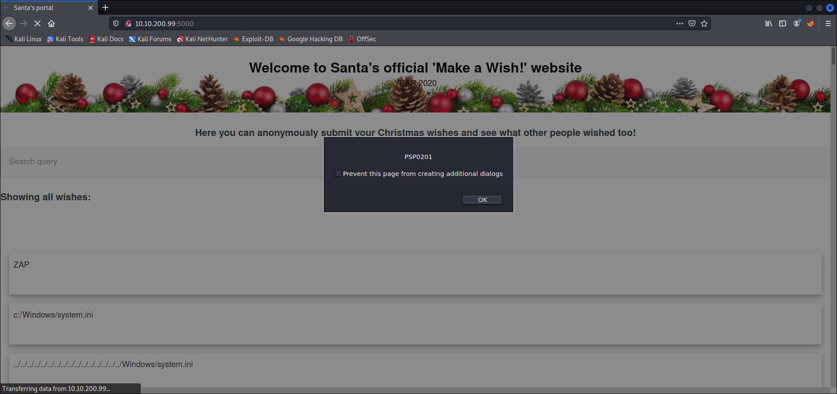

**Thought Process/Methodology:**

Using the reference given, which was the Owasp Cheat Sheet, we could see the explanation for input validation level and regular expression for a US Zip code. When going to the site, we say search inputs and comments that can be entered in by user. This shows the vulnerability type to exploit using XSS. Then, we used the search query to search for something. This gives us the query string that can be abused. After that, using OwaspZap application we ran an automated scan through the website. Once done, it gave us the amount of alert results and type of priorities, that included XSS, for us to exploit. After running XSS exploits, we closed the browser and revisited the site to see whether the XSS attacks persisted.

**Day 7: Networking – The Grinch Really Did Steal Christmas**

**Tools used**: Kali Linux, Firefox

**Solution/walkthrough**:

Question 1

Opened Wireshark, and opened pcap1.pcap.

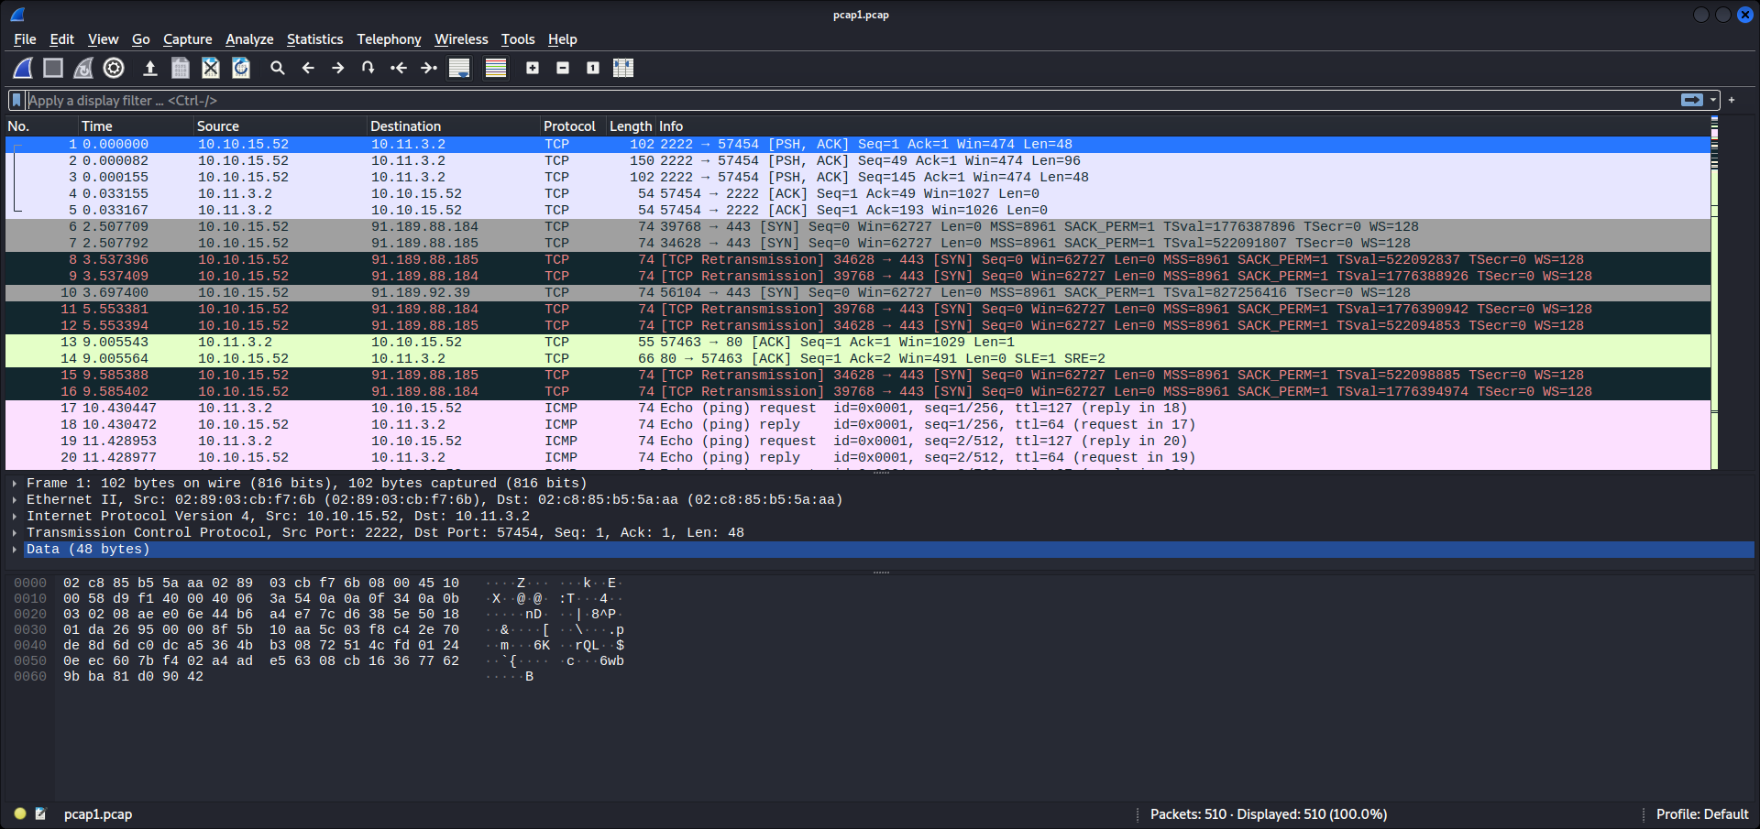

Search for the first IP address that has ICMP protocol.

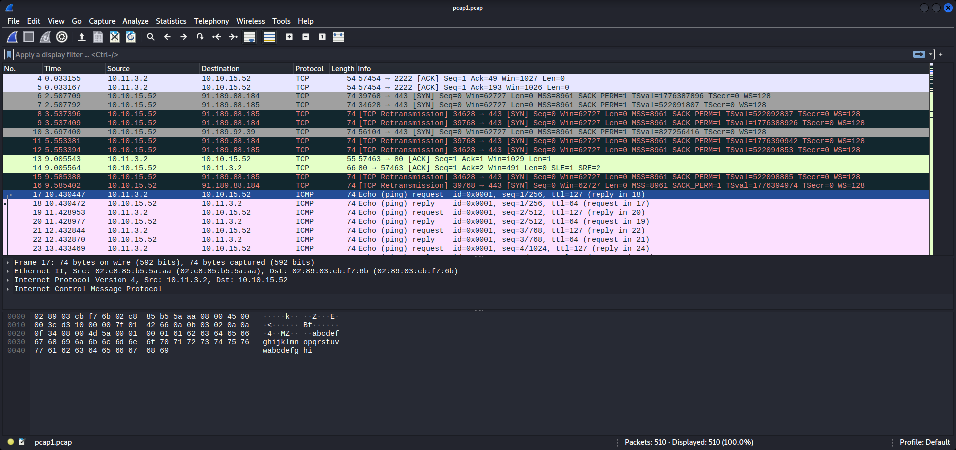

Question 2

Use the search filter to specify for HTTP GET requests using command.

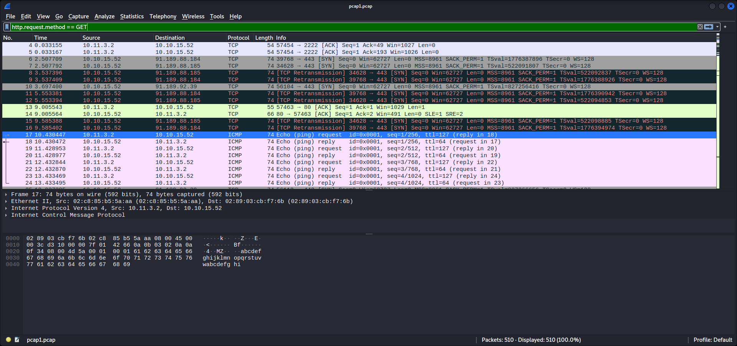

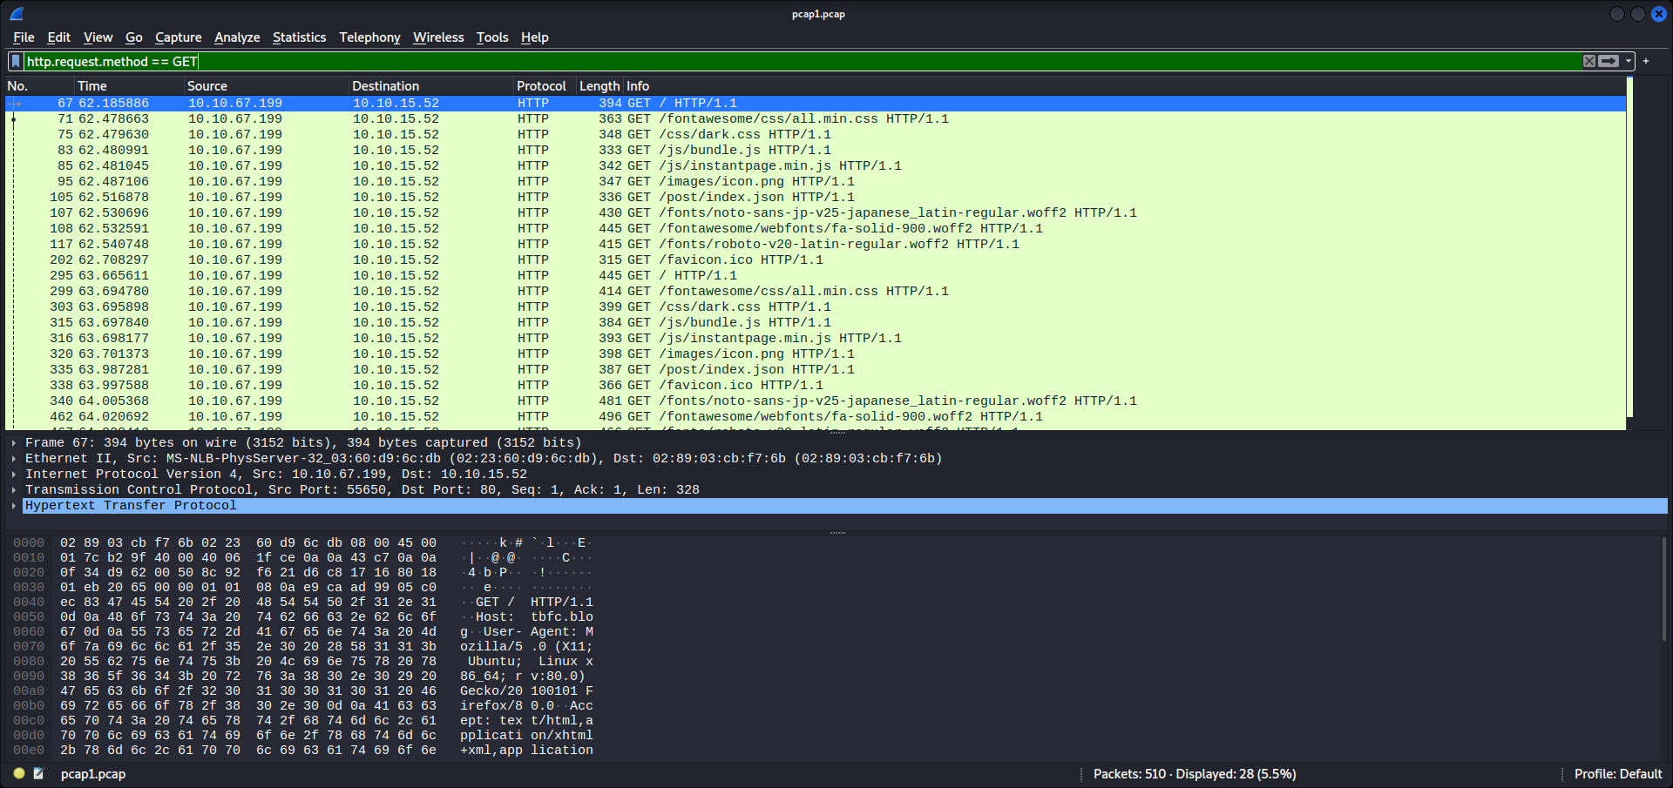

Question 3

Look for posts that could be an article.

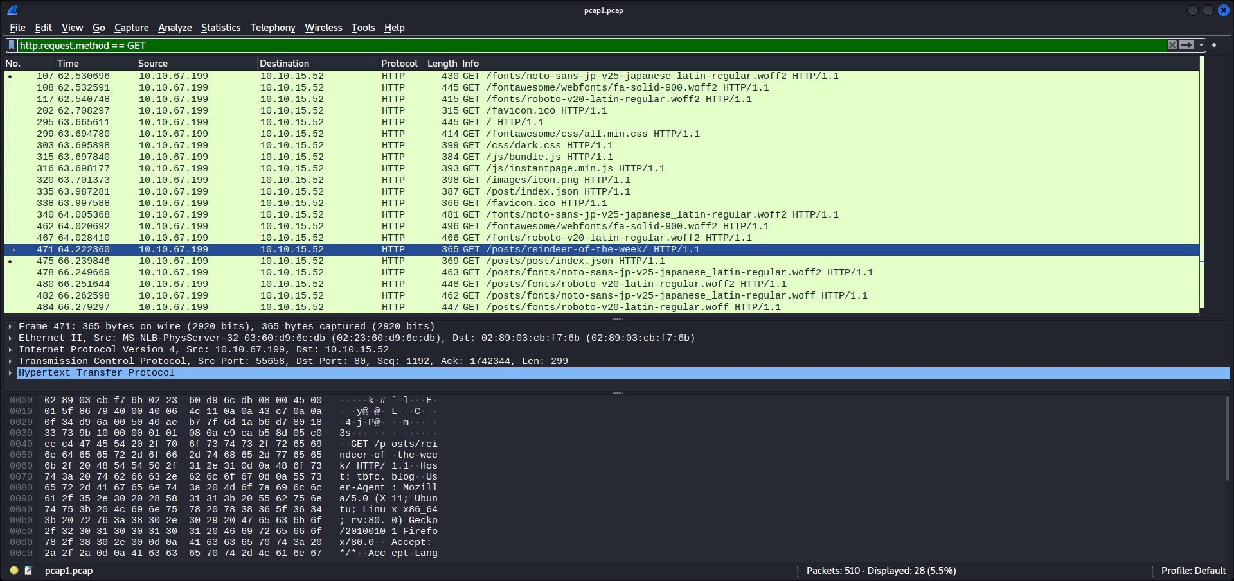

Question 4

Open pcap2.pcap on Wireshark.

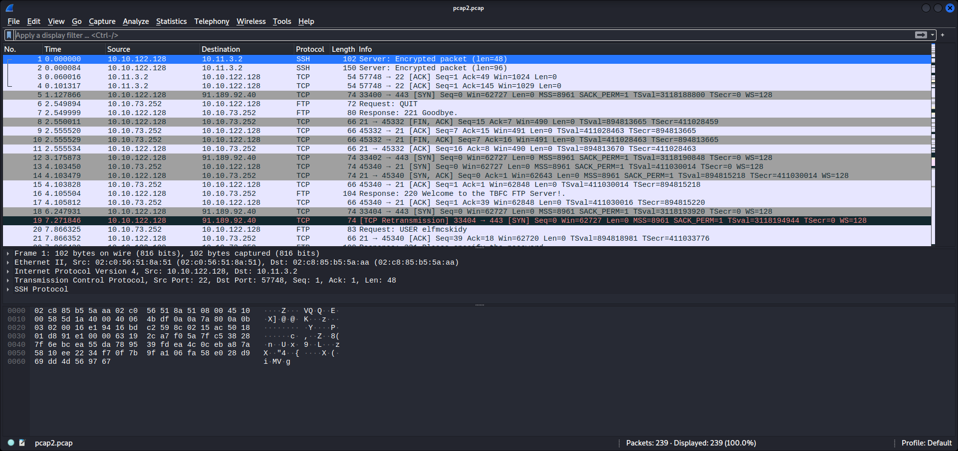

Use the search filter for TCP protocols under port 21.

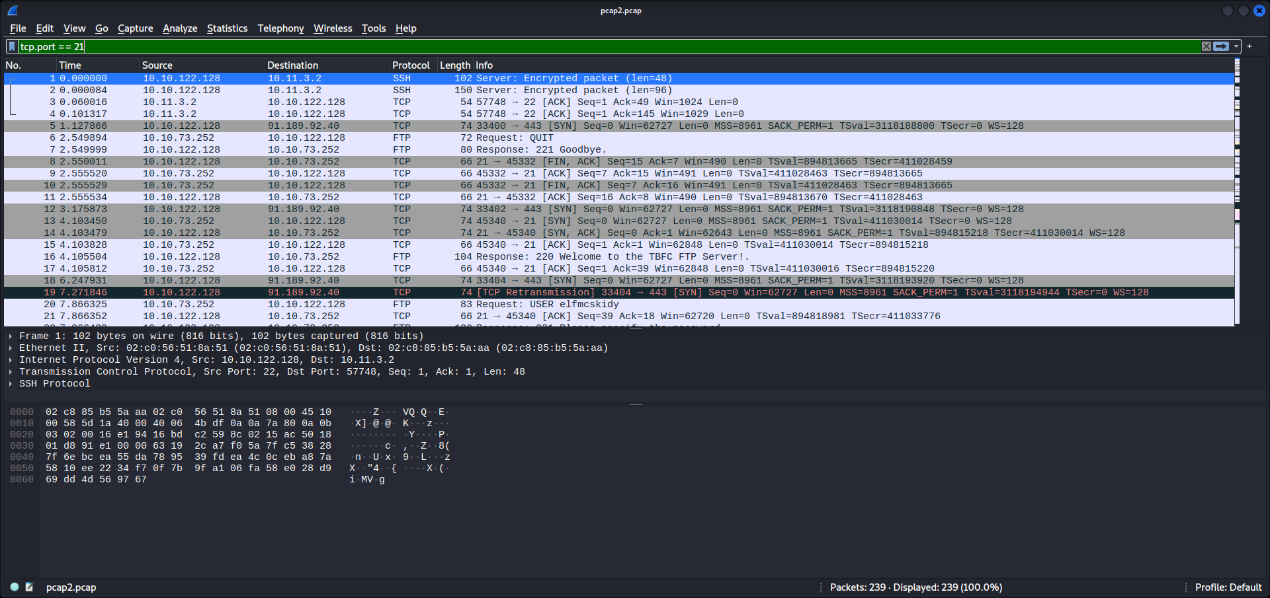

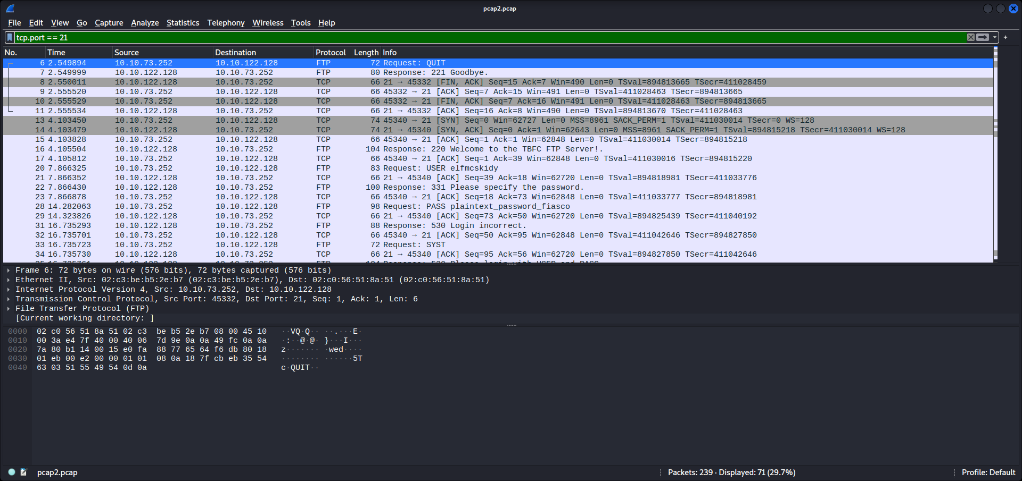

Look for the password entered.



Question 5

Without any filters, search for the protocols with encrypted packets.



Question 6

Search filter for ARP communications.

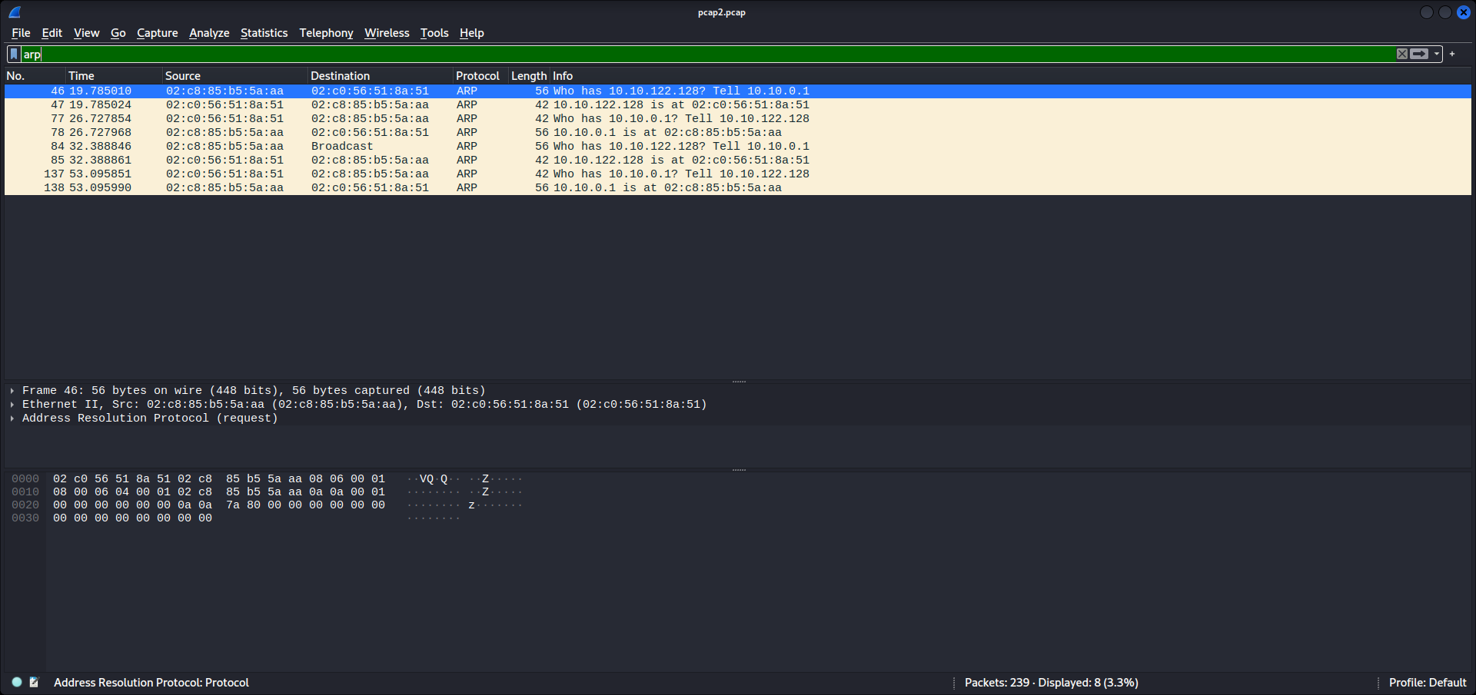



Question 7

Look through pcap3.pcap for any informations.

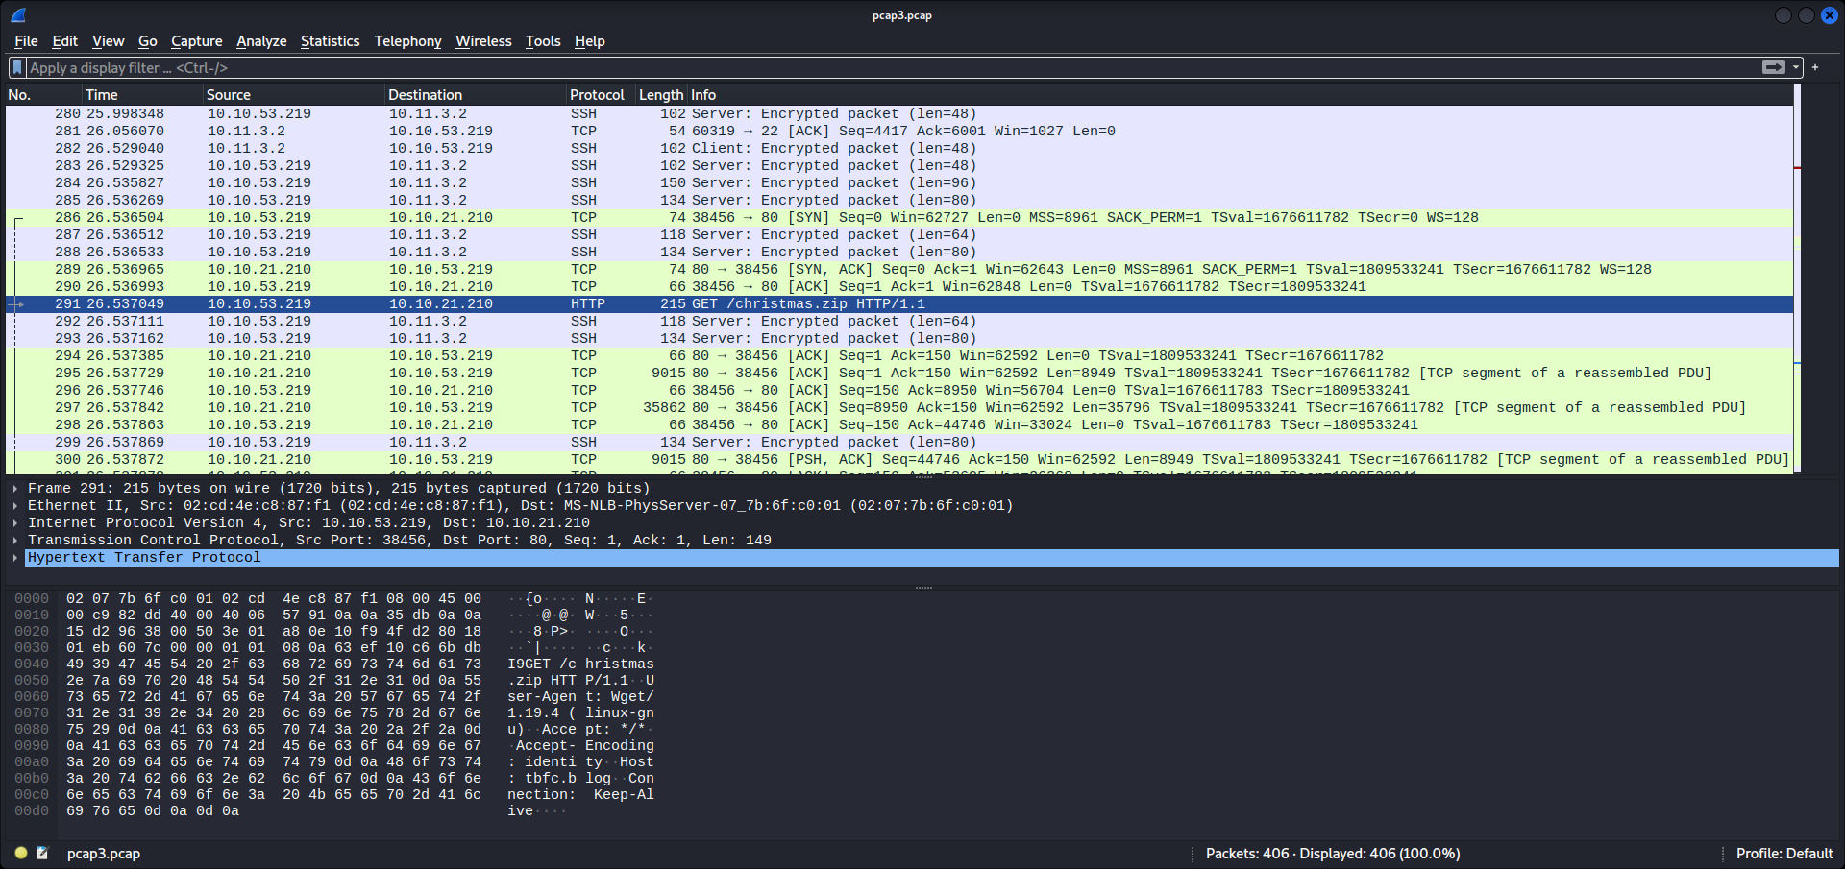

Follow the TCP stream.

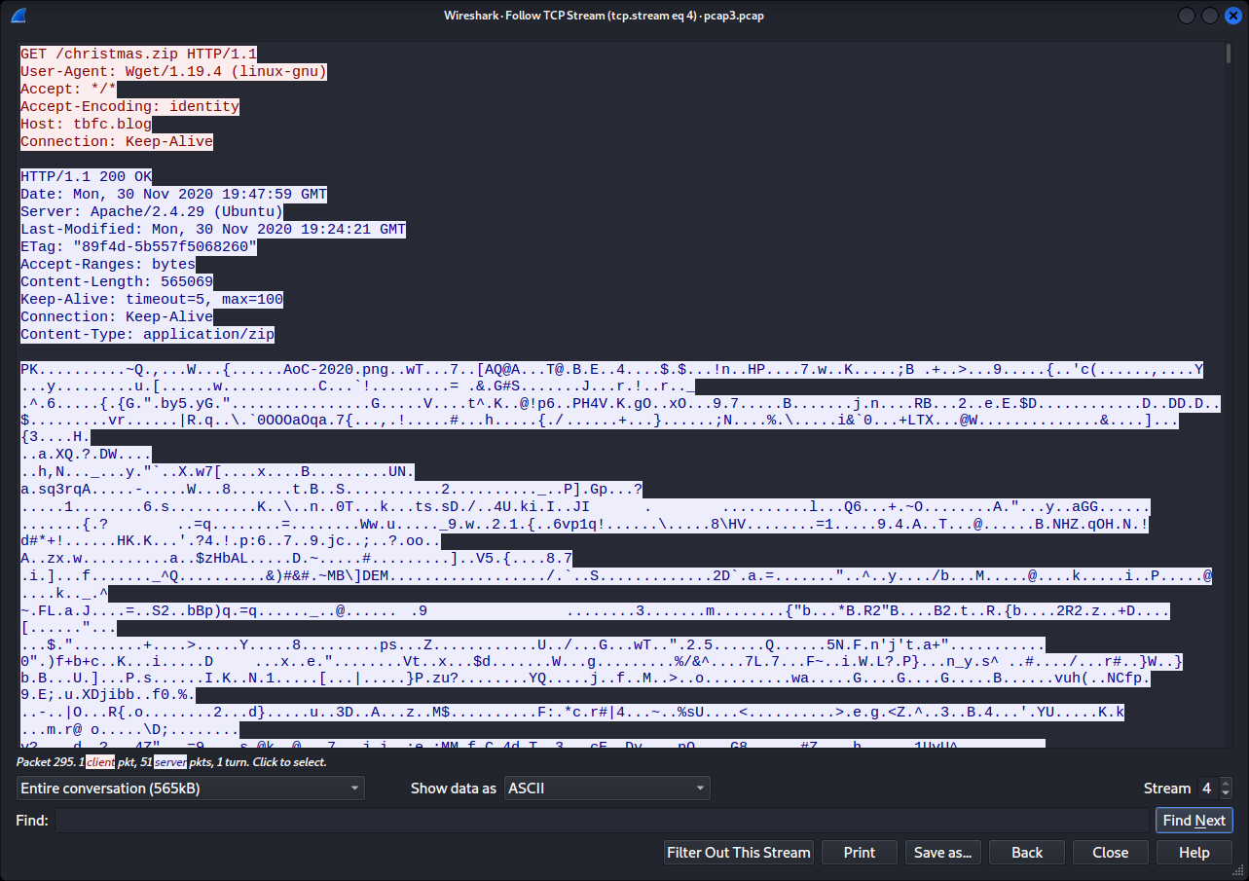

Export Objects HTTP.

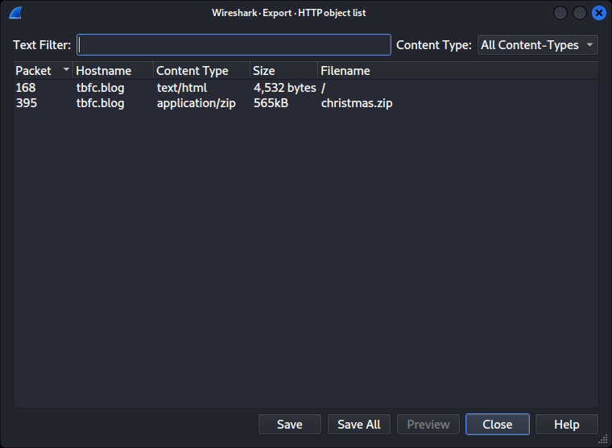

Save the Christmas.zip file and open it.

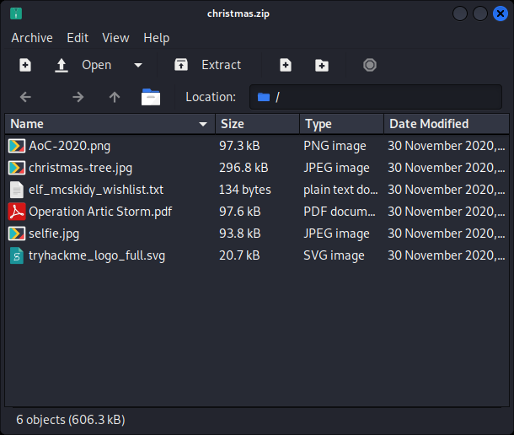

Look into wishlist.txt file.

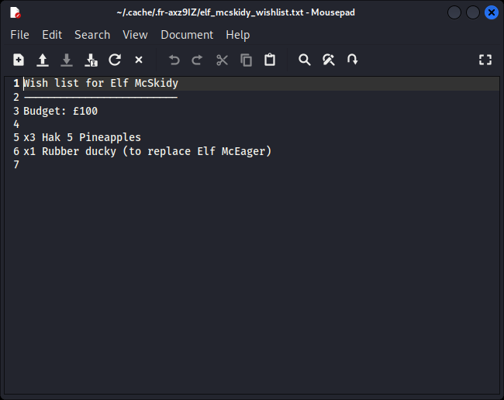

Question 8

Open Operation Artic Storm.pdf and search for the author.

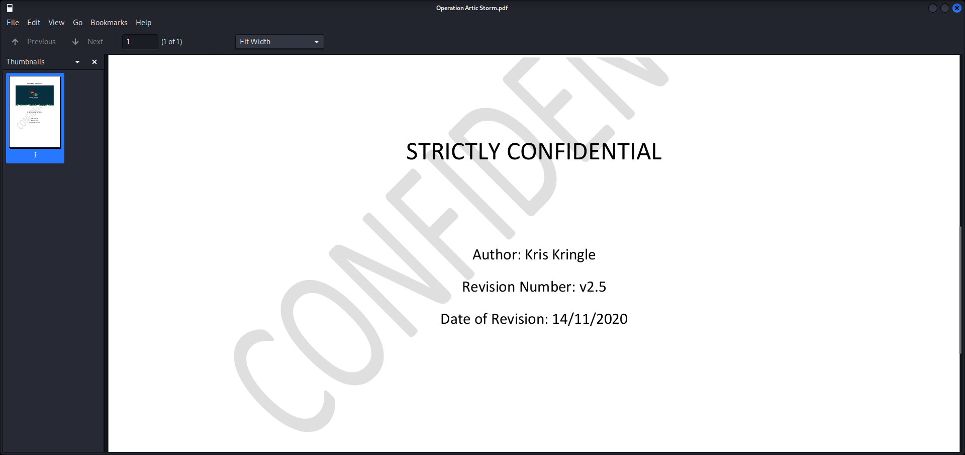

**Thought Process/Methodology:**

Using Wireshark, we analysed pcap1.pcap file first. We looked for an IP address that had a ping request using ICMP protocol. Then, we used a filter for HTTP GET methods to look for articles visited. Next was to look through pcap2.pcap. Since we are looking for an FTP traffic, we filtered for TCP protocols with port 21 and found the password. Without any search filters, we saw encrypted packets with SSH protocols. Search filtering for arp gives us the communications for the MAC address needed. Lastly, we analysed through pcap3.pcap. Looking through the output, we thought there was a file downloaded from the TCP stream. Following it shows an application/zip Content-Type. Thus we went to export Objects in HTTP and found the Christmas.zip file. From there, we discovered the wishlist.txt and Operation Artic Storm.pdf.

**Day 8 : Networking- What’s under the Christmas Tree?**

**Tool used:**Kali Linux,Firefox,Nmap,Google

**Solution/Walkthrough:**

Question 1

Make a quick google search

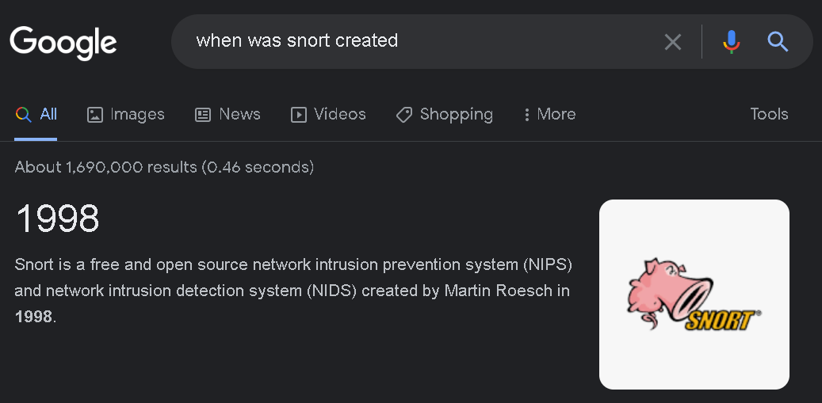

Question 2

Use Nmap on the on the machine IP

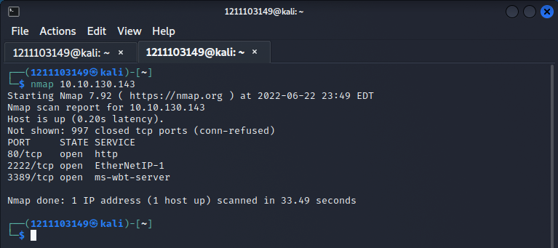

Question 3,4,5 and 6

Use the -A flag on the machine ip

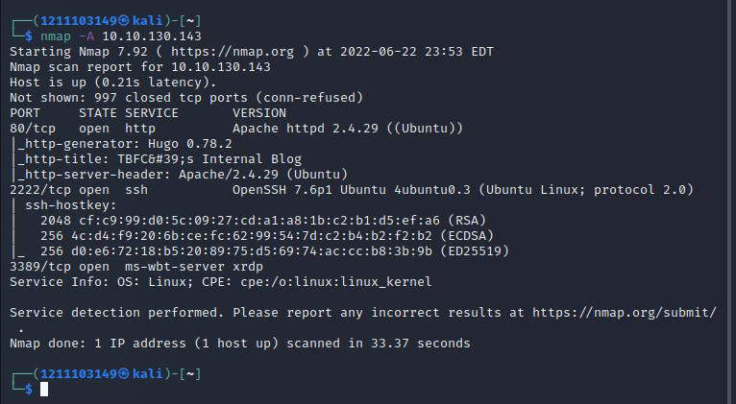

**Thought Process/Methodology:**

Using Nmap on the ip will let us discover the host and services running on it so we’ll be able to get the ports it's running. Then because we aren't afraid of getting detected, we used the -A(aggressive) flag to display even more information about the ip. With that, we can get all the information we needed, which were what distribution of Linux it was running, what version of apache it was using, what was running on the port 2222 and finally what the ip was most likely used for.

**Day 9 : Networking - Anyone can be Santa!**

**Tool used:** Kali Linux, Firefox

**Solution/Walkthrough:**

Question 1

Log in to the victim machine’s FTP servers with anonymous mode.

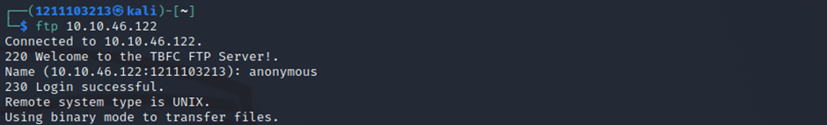

List out the files found using ls command.

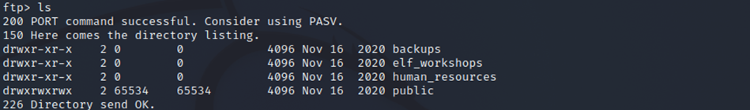

Question 2

Look for directory that has data to be viewed.

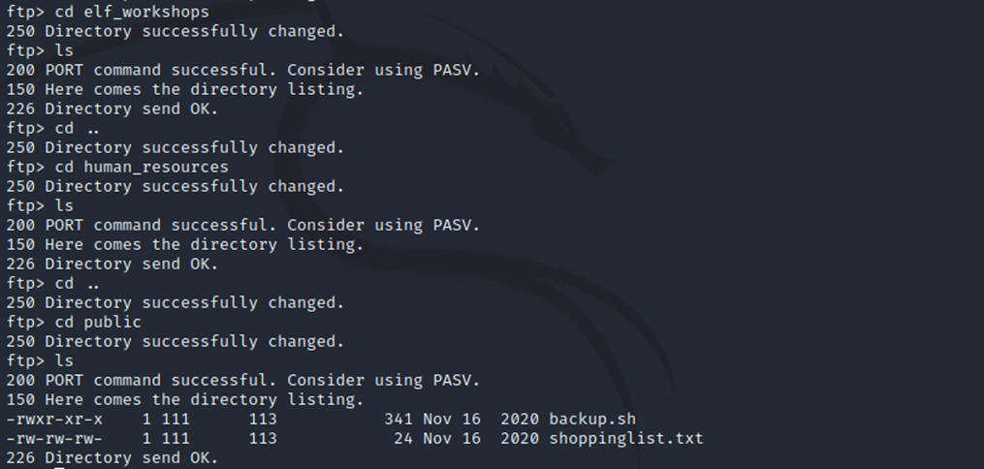

Question 3

Download the files in the public directory.

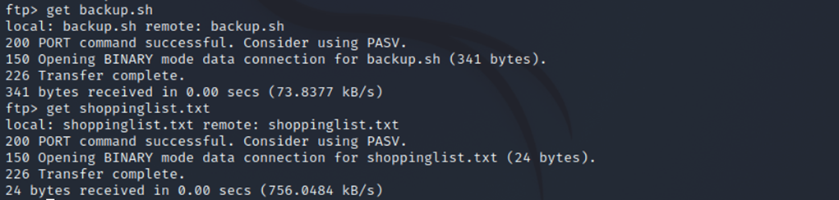

Open the shell using a text editor.

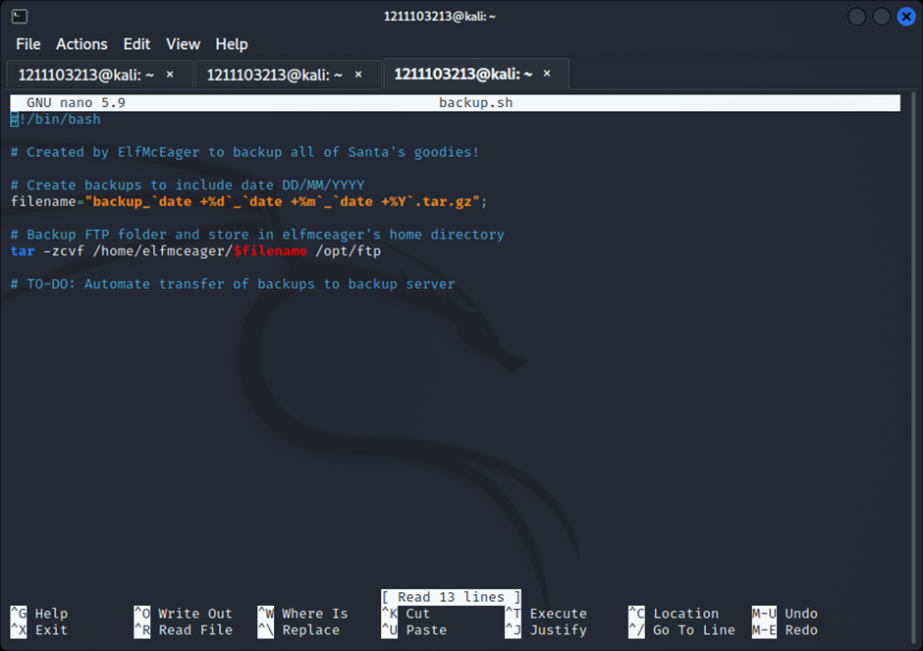

Question 4

Open the shoppinglist.txt file.

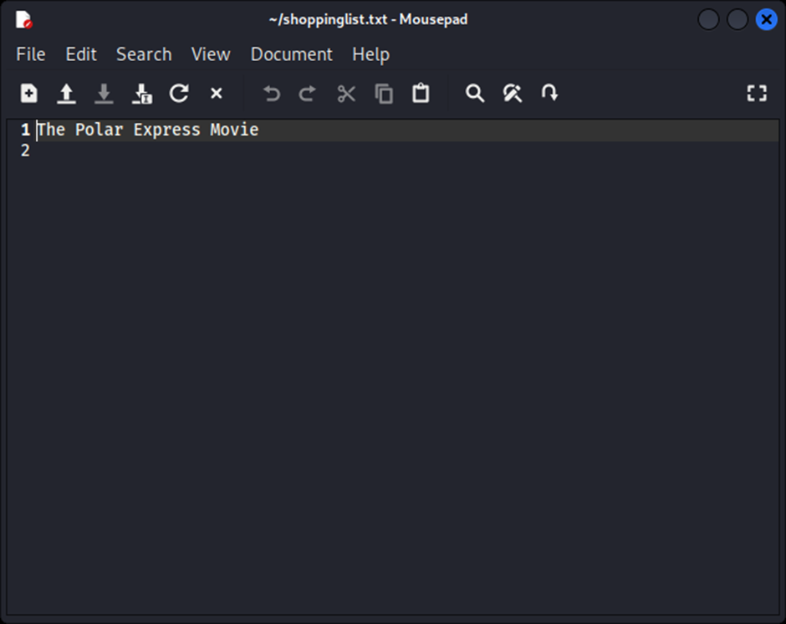

Question 5

With the pentesters sheet, add command to generate a shell in the backup.sh file and save it.

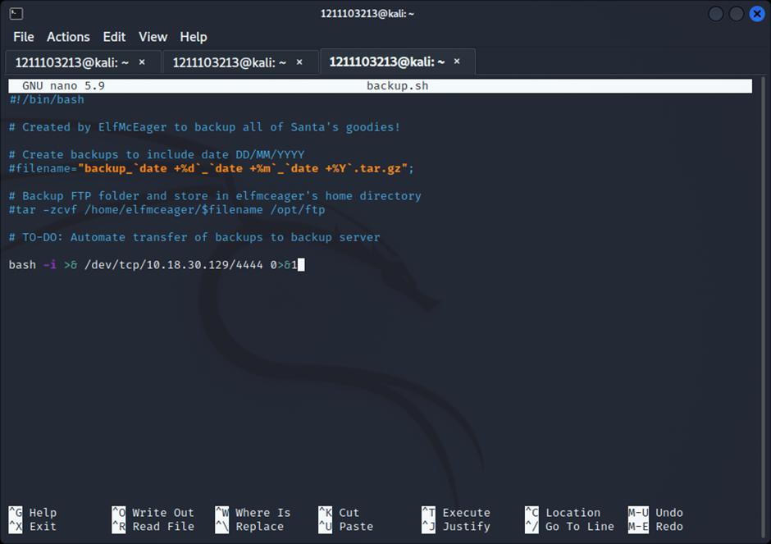

Setup a listener using netcat.

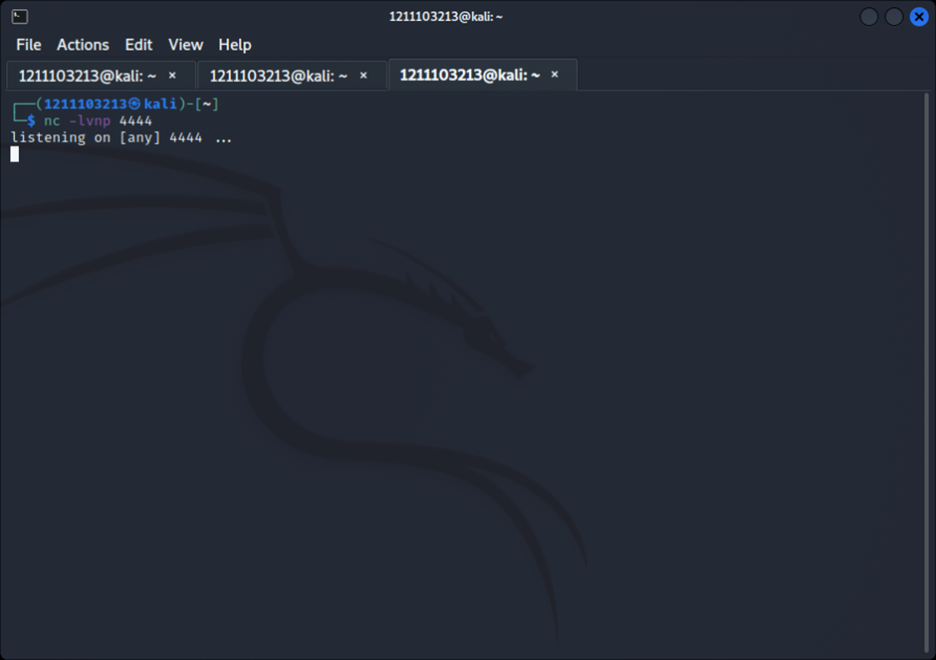

Go back to the victim machine’s FTP server and upload the shell with malicious command.

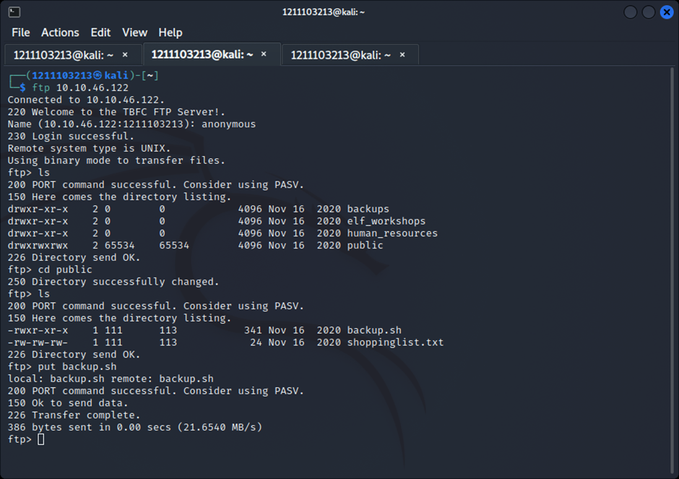

Look back at the netcat listener.

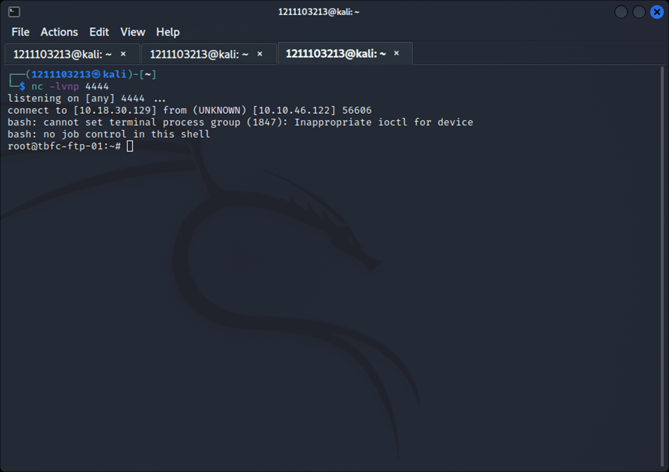

Search for the flag.

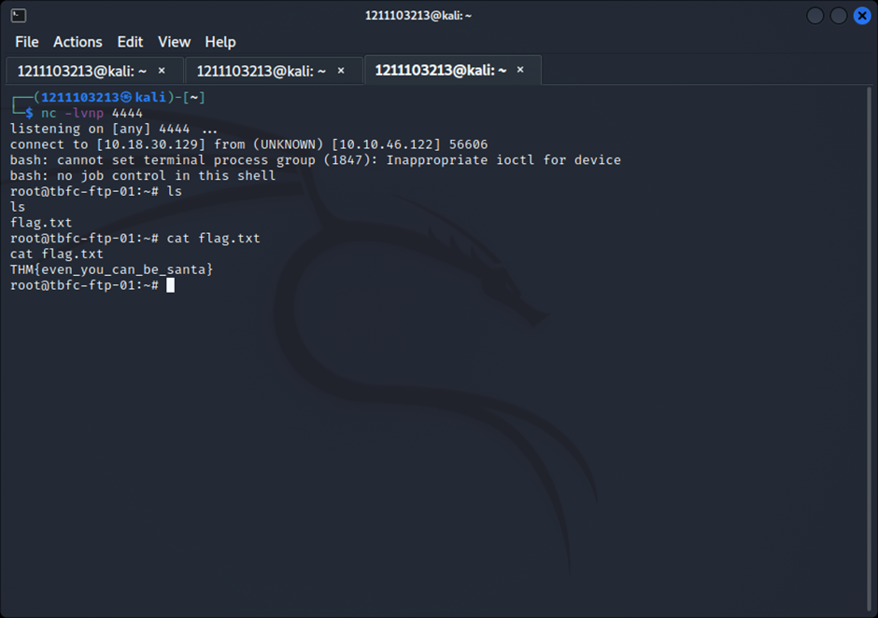

**Thought Process/Methodology:**

After accessing the victim’s FTP server using anonymous mode, we looked for the directories available. Only the public directory could be accessed. In there, there was a shell file and text file. Using the get command, we downloaded both files to our device. Opening the text file reveals Santa’s movie to be bought. Then, opening the shell file allows us to insert a malicious code that runs a shell for us. Next, we prepared a shell listener using netcat. Going back to the victim’s FTP server, we can upload the shell with our malicious code into the same public directory. Back to our netcat listener, we were able to gain root access on our victim’s machine with the reverse shell. Thus, we searched and obtained the flag.

**Day 10 : Networking - Don’t Be sElfish!**

**Tools used:** Kali Linux, Firefox

**Solution/walkthrough:**

Question 1

open terminal and use enum4linux help command. Search for the options list.

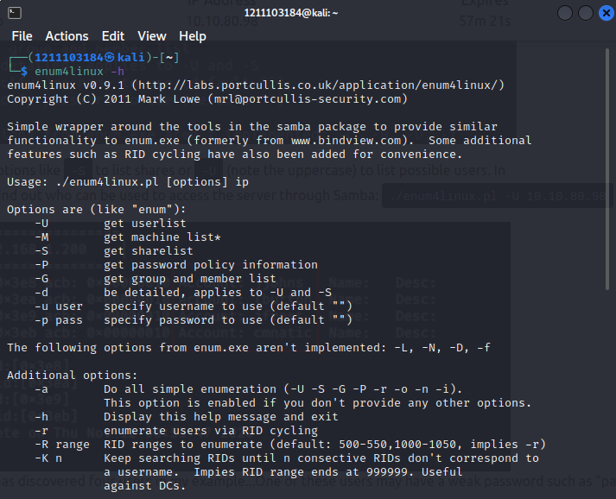

Question 2

Use enum4linux userlist command followed by the IP address given.

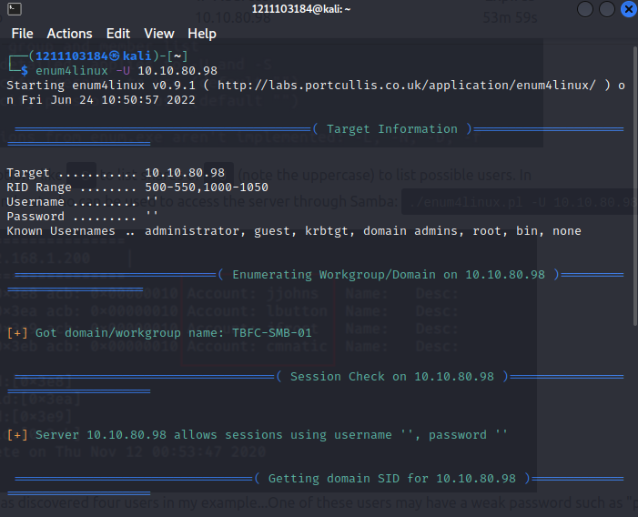

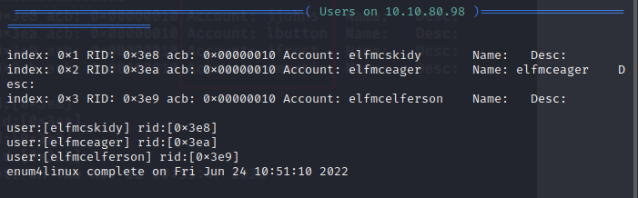

Question 3

Use enum4linux sharelist command with the IP address given.

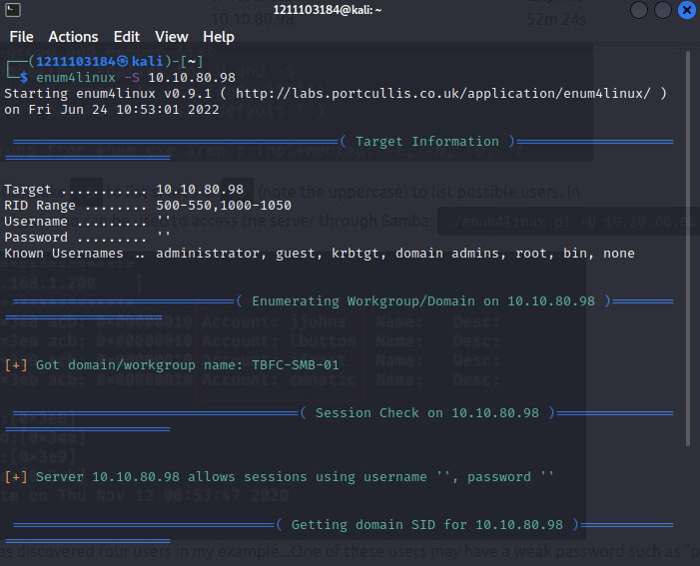

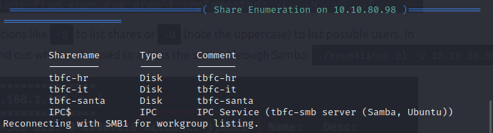

Question 4

Use smbclient tool and do trial and error method for every sharelist.

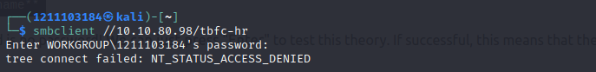

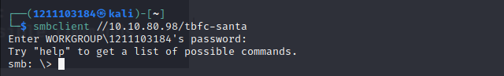

Question 5

Use the help command and search through the command lists.

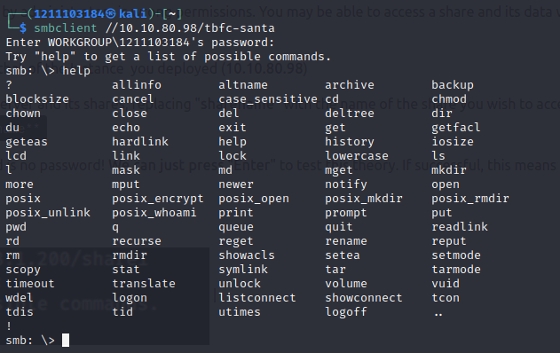

Type **dir** in the terminal to search for directory.

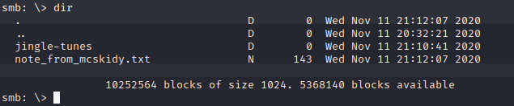

Get the note from McSkidy and read it.

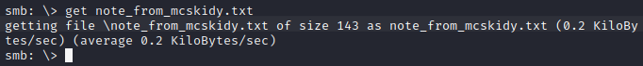

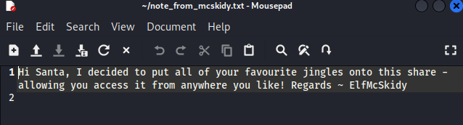

**Thought Process/Methodology:**

After you get the IP address, use enum4linux help command and look for every command list given. Then, use the -U command to get the user lists. Likewise, use the -S command to acquire the share lists and use the smbclient tool for every sharelist until you get the one without password. Look through every Samba command and use the dir command. Subsequently, you will get the jingle tunes and a note from McSkidy.